# Nin10do Parts List

This is a list of all the parts you need to build a Nin10do game console.  
You don’t need to buy the products in the linked shops. This is just for clarification. All the parts are pretty easy to obtain in every country.

**3d printed Case**

**4mm rod**

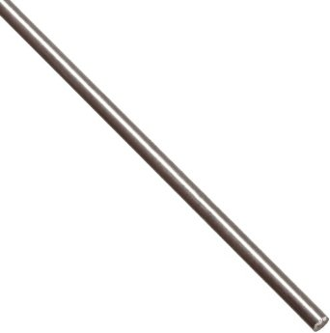

**Pulleys 4mm**

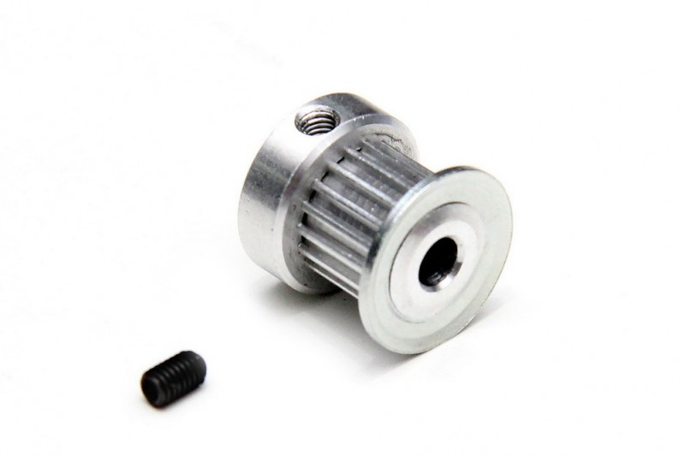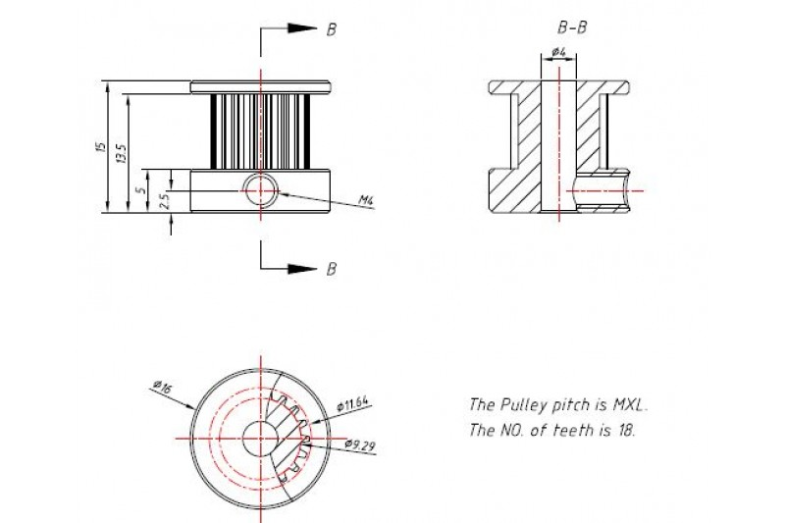

<http://www.makeblock.cc/timing-pulley-18t-pair/>

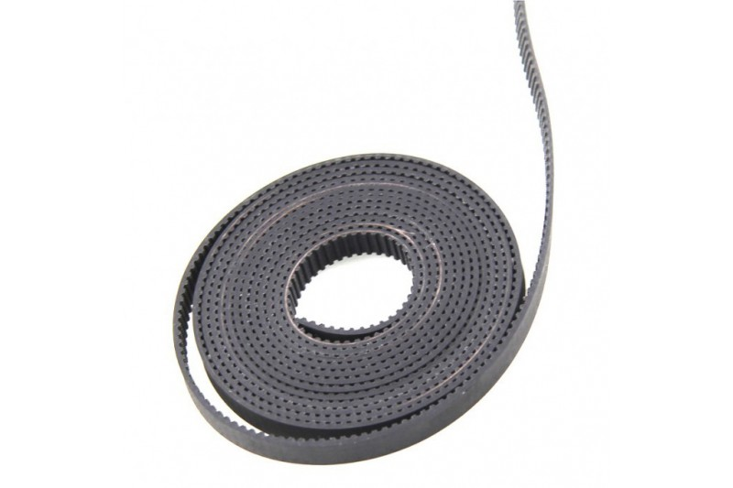

**Timing Belt Standard: MXL**

Pitch: 2.032mm

Width: 6.6 mm

Material: Neoprene

Length: 2m

http://www.makeblock.cc/timing-belt-2m-open-end/

**Raspberry Pi 2**

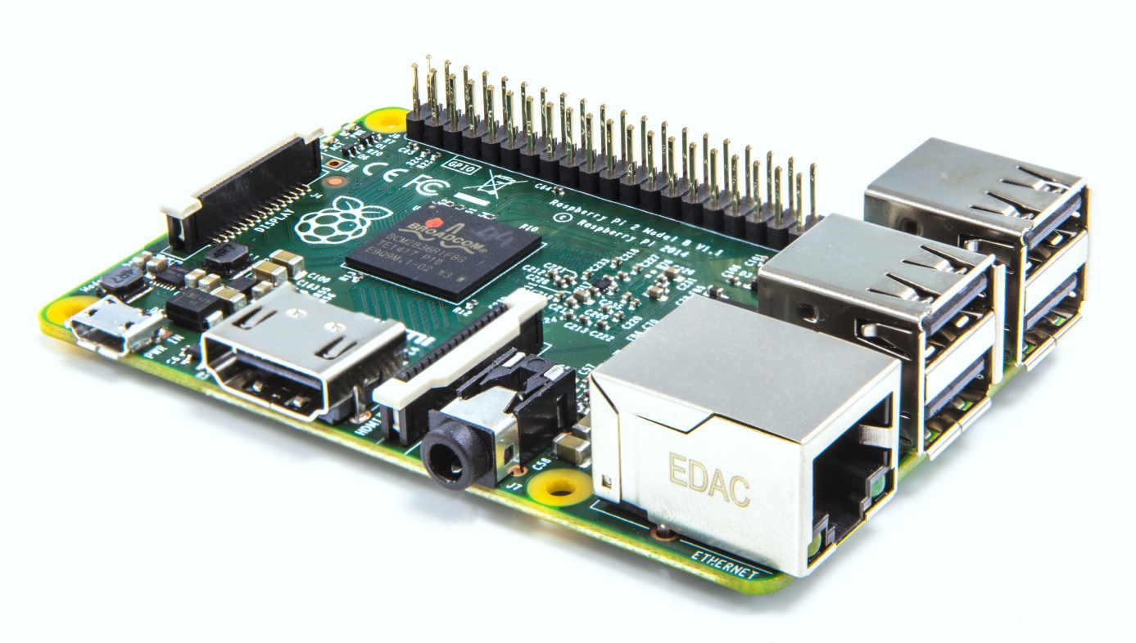

**ATX Raspi**

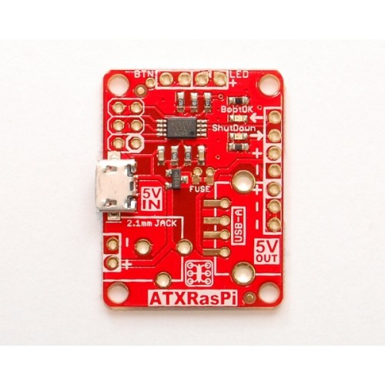

<https://lowpowerlab.com/shop/ATXRaspi-R2>

**5mm Leds**

1 x Red Led 4 x Blue (I use extra bright)

**Led holder**

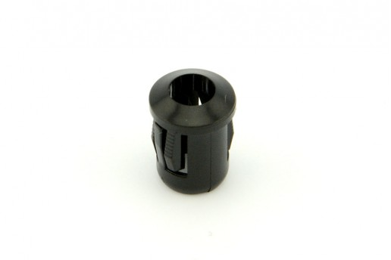

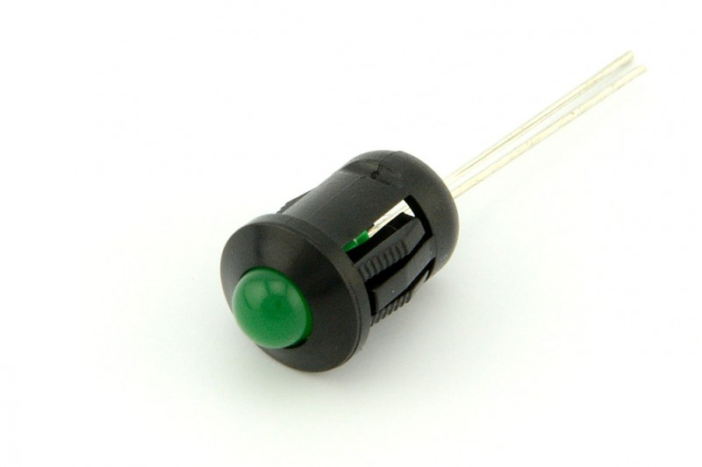

Hole diameter: 8.1mm

<https://www.kiwi-electronics.nl/led-houder-5mm-5-stuks?search=led&limit=75>

**Led Push Buttons 2 x (choose own colors)**

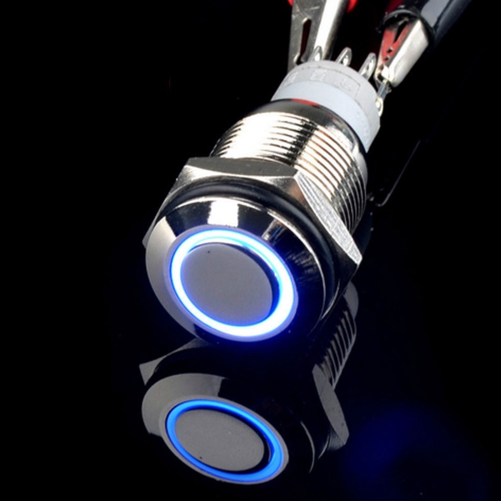

<http://www.ebay.com/itm/New-16mm-Blue-12V-LED-Angel-Eye-Metal-Momentary-car-Push-Button-Switch-/131545385616?hash=item1ea0b74a90>

16mm diameter.

**Barrel Jack Adapter + DC Jack**

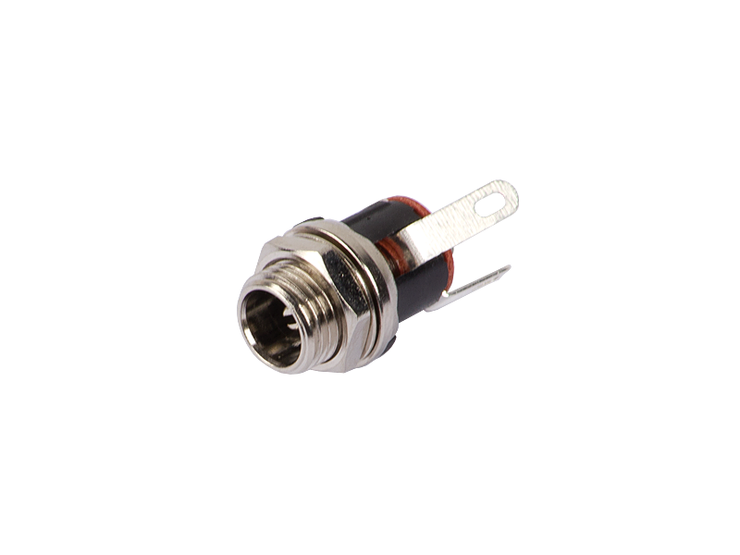

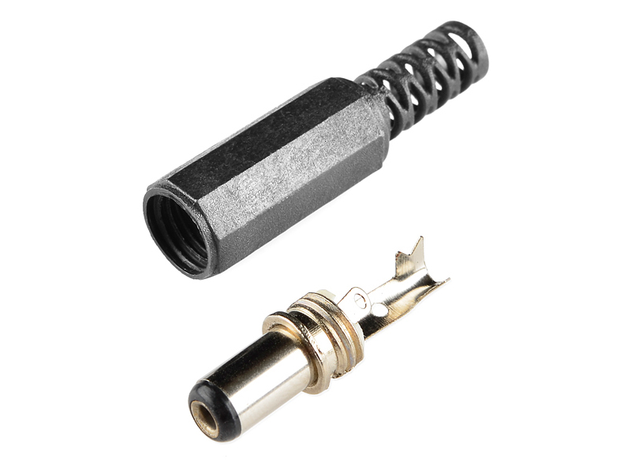

<https://iprototype.nl/products/accessoires/power/dc-barrel-jack-panel-mount>

**HDMI cable + Connector**

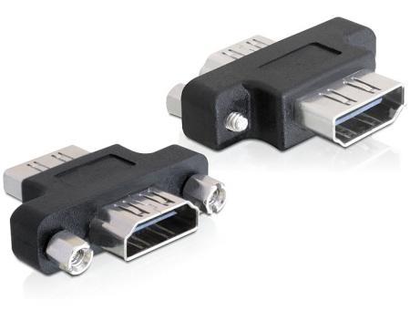

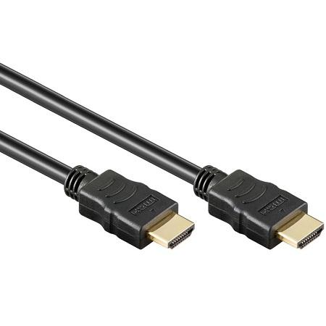

<http://www.allekabels.nl/hdmi-kabel/1779/1192956/hdmi-kabel-14-high-speed-aanbieding.html>

<http://www.allekabels.nl/hdmi-koppelstuk/1783/1164460/hdmi-a-koppelstuk.html>

**Cat cable + RJ45 Connector**

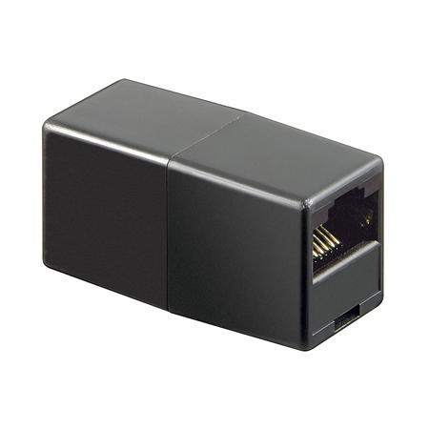

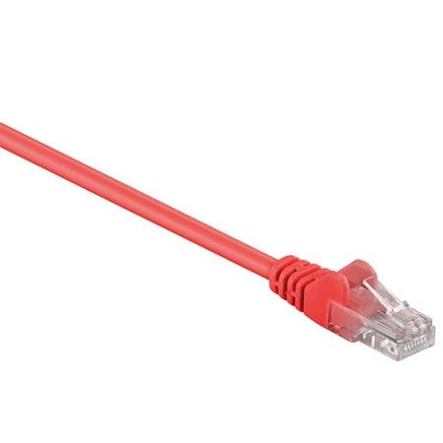

<http://www.allekabels.nl/utp-kabel/7390/1286739/netwerkkabel-cat-5e-uutp.html>

**Stepper Motor 5v with ULN2003 driver**

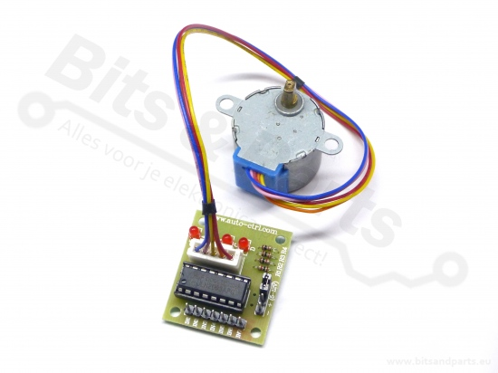

**Dupont male, female and headers (also electrical wire and a crimping tool)**

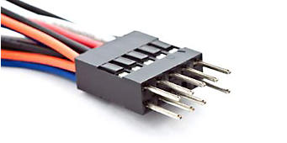

(search for dupont connectors online)

**USB Hub 4 ports:**

# LogiLink USB 2.0 hub 4 ports

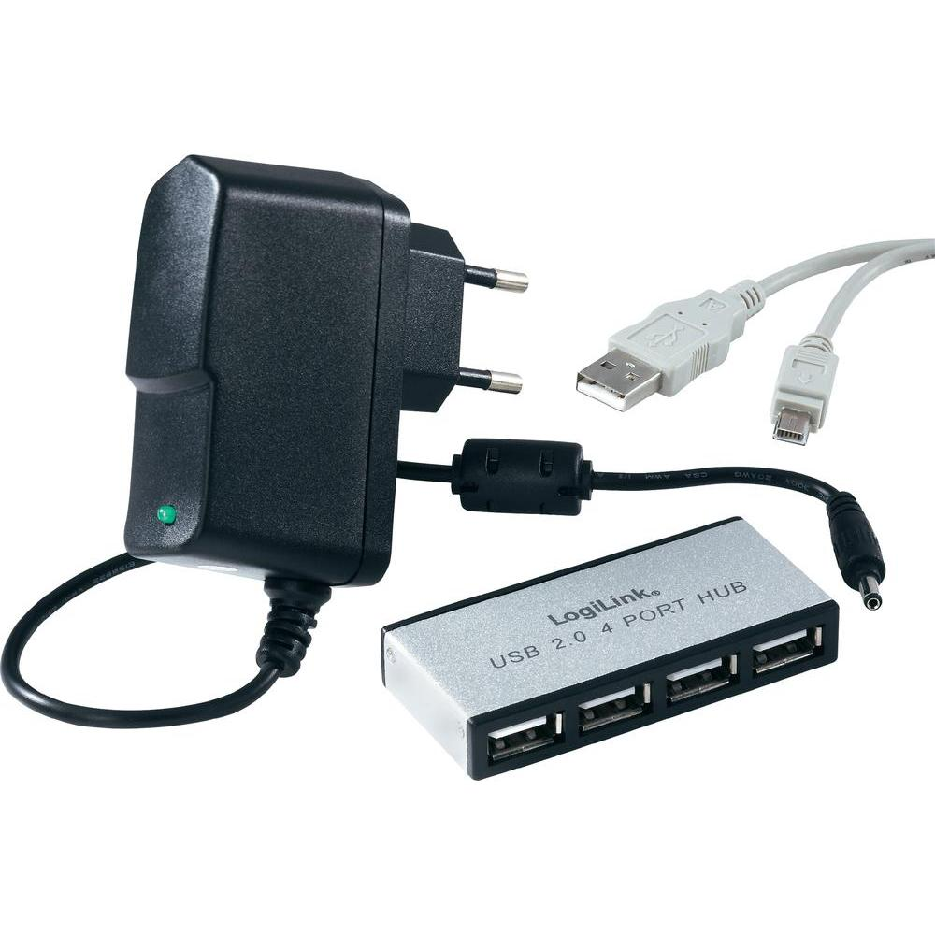

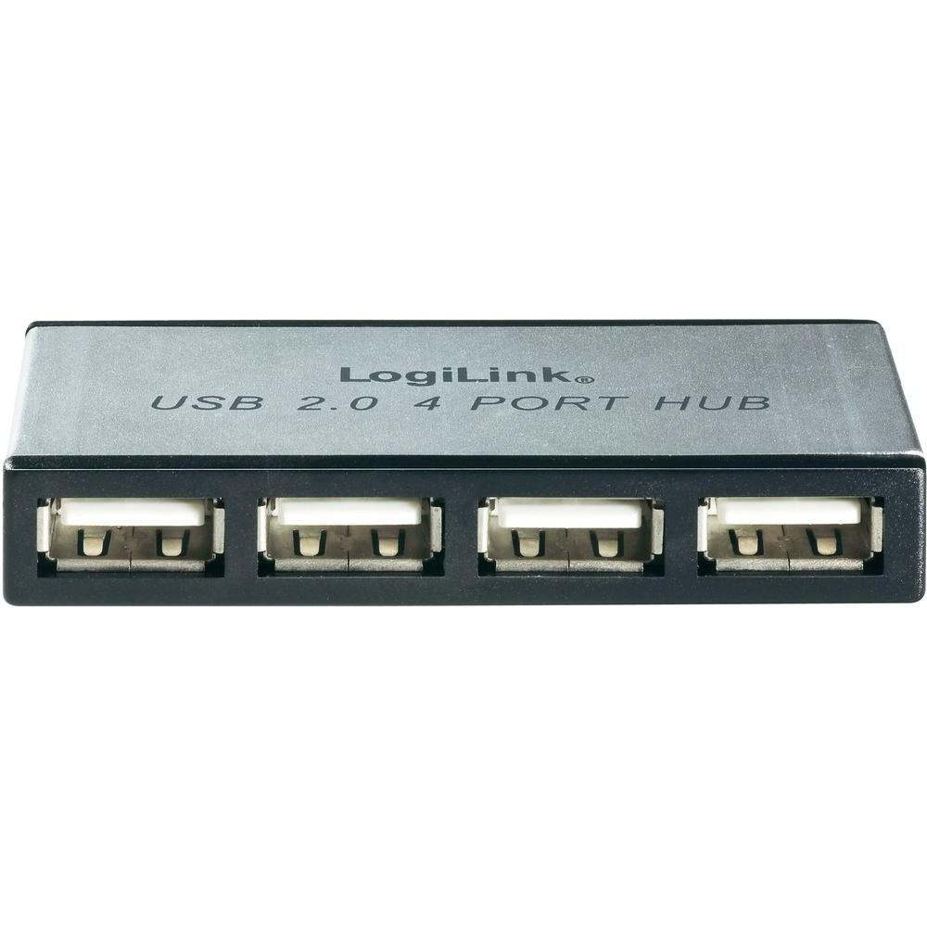

<https://www.conrad.nl/nl/4-poorten-usb-20-hub-logilink-zilver-971895.html>